
Name: Mathimozhi ER - 192321121
LAB MANUAL EXPERIMENTS

1. 8-Puzzle Problem
Aim: To solve the 8-puzzle problem using Python.
Procedure:
• Open Python IDLE.
• Type the program and save it as a .py file.
• Press F5 to run the program.
• Enter the required input, if any.
• Observe and verify the output.
PROGRAM:
from collections import dequestart = (1,2,3,4,0,6,7,5,8)goal = (1,2,3,4,5,6,7,8,0)q = deque([(start, [])])seen = {start}while q: s, path = q.popleft() if s == goal: print(path + [s]); break z = s.index(0) for n in [z-3,z+3,z-1,z+1]: if 0 <= n < 9 and (abs(z-n)==3 or z//3==n//3): t = list(s); t[z],t[n] = t[n],t[z]; t = tuple(t) if t not in seen: seen.add(t); q.append((t,path+[s]))

OUTPUT:
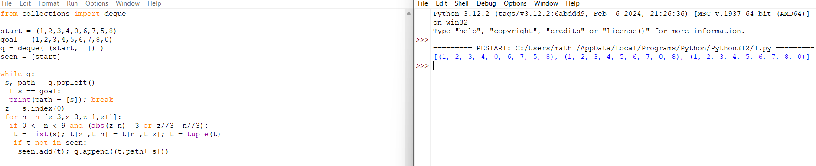Result: The 8-puzzle was solved using Breadth First Search.

2. 8-Queen Problem
Aim: To place eight queens on a chessboard without attacking each other.
Procedure:
• Open Python IDLE.
• Type the program and save it as a .py file.
• Press F5 to run the program.
• Enter the required input, if any.
• Observe and verify the output.
PROGRAM:
def solve(row, cols, d1, d2, ans): if row == 8: print(ans); return True for c in range(8): if c not in cols and row-c not in d1 and row+c not in d2: if solve(row+1, cols|{c}, d1|{row-c}, d2|{row+c}, ans+[c]): return True return Falsesolve(0,set(),set(),set(),[])

OUTPUT
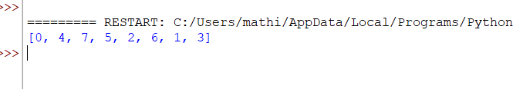
Result: Eight queens were placed safely on the chessboard.

3. Water Jug Problem
Aim: To measure 2 litres using 4-litre and 3-litre jugs.
Procedure:
• Open Python IDLE.
• Type the program and save it as a .py file.
• Press F5 to run the program.
• Enter the required input, if any.
• Observe and verify the output.
PROGRAM:
from collections import dequeq = deque([((0,0),[])])seen = set()while q: (a,b),p = q.popleft() if (a,b) in seen: continue seen.add((a,b)) if a == 2: print(p+[(a,b)]); break states = [(4,b),(a,3),(0,b),(a,0), (a-min(a,3-b),b+min(a,3-b)), (a+min(b,4-a),b-min(b,4-a))] for s in states: q.append((s,p+[(a,b)]))
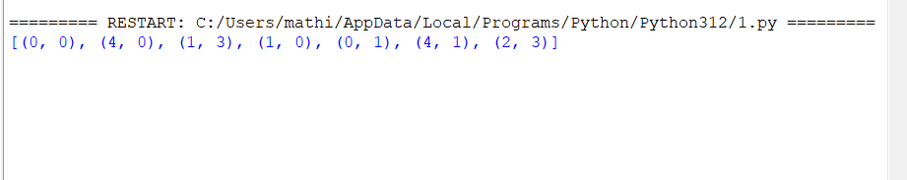
Result: The water jug problem was solved to obtain 2 litres.

4. Crypt-Arithmetic Problem
Aim: To solve a crypt-arithmetic puzzle using Python.
Procedure:
• Open Python IDLE.
• Type the program and save it as a .py file.
• Press F5 to run the program.
• Enter the required input, if any.
• Observe and verify the output.
PROGRAM:
from itertools import permutationsfor p in permutations(range(10), 8): s,e,n,d,m,o,r,y = p if s and m and 1000*s+100*e+10*n+d + 1000*m+100*o+10*r+e == 10000*m+1000*o+100*n+10*e+y: print("SEND + MORE = MONEY") print(1000*s+100*e+10*n+d, "+", 1000*m+100*o+10*r+e, "=", 10000*m+1000*o+100*n+10*e+y) break
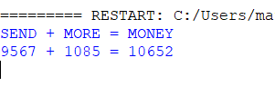
Result: The crypt-arithmetic puzzle was solved by assigning digits to letters.

5. Missionaries and Cannibals Problem
Aim: To move missionaries and cannibals safely across a river.
Procedure:
• Open Python IDLE.
• Type the program and save it as a .py file.
• Press F5 to run the program.
• Enter the required input, if any.
• Observe and verify the output.
PROGRAM:
from collections import dequeq = deque([((3,3,1),[])])seen = set()moves = [(1,0),(2,0),(0,1),(0,2),(1,1)]while q: (m,c,b),p = q.popleft() if (m,c,b) in seen: continue seen.add((m,c,b)) if (m,c,b)==(0,0,0): print(p+[(m,c,b)]); break for x,y in moves: a,d = (m-x,c-y) if b else (m+x,c+y) if b and x+y>0 or not b and x+y>0: if 0<=a<=3 and 0<=d<=3 and (a==0 or a>=d) and (a==3 or 3-a>=3-d): q.append(((a,d,1-b),p+[(m,c,b)]))
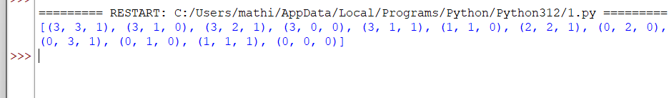
Result: The missionaries and cannibals problem was solved using state-space search.

6. Vacuum Cleaner Problem
Aim: To clean two rooms using a simple vacuum cleaner agent.
Procedure:
• Open Python IDLE.
• Type the program and save it as a .py file.
• Press F5 to run the program.
• Enter the required input, if any.
• Observe and verify the output.
PROGRAM:
rooms = {'A':'Dirty','B':'Dirty'}
for room in rooms:
if rooms[room] == 'Dirty':
print("Clean",room)
rooms[room] = 'Clean'
print(rooms)
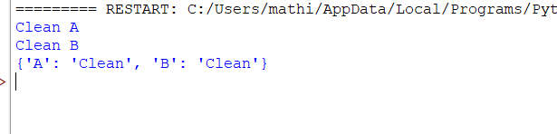
Result: Both rooms were cleaned successfully.

7. Breadth First Search (BFS)
Aim: To implement BFS in Python.
Procedure:
• Open Python IDLE.
• Type the program and save it as a .py file.
• Press F5 to run the program.
• Enter the required input, if any.
• Observe and verify the output.
PROGRAM:
from collections import deque
g = {'A':['B','C'],'B':['D'],'C':['E'],'D':[],'E':[]}
q = deque(['A'])
v = ['A']while q: n = q.popleft()
print(n,end=' ')
for x in g[n]:
if x not in v:
v.append(x)
q.append(x)
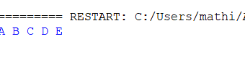
Result: The graph was traversed using BFS.

8. Depth First Search (DFS)
Aim: To implement DFS in Python.
Procedure:
• Open Python IDLE.
• Type the program and save it as a .py file.
• Press F5 to run the program.
• Enter the required input, if any.
• Observe and verify the output.
PROGRAM:
g = {'A':['B','C'],'B':['D'],'C':['E'],'D':[],'E':[]}def dfs(n): print(n,end=' ') for x in g[n]: dfs(x)dfs('A')
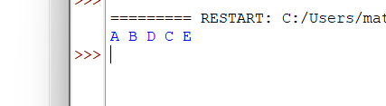
Result: The graph was traversed using DFS.

9. Travelling Salesman Problem (TSP)
Aim: To find the minimum-cost route for visiting all cities.
Procedure:
• Open Python IDLE.
• Type the program and save it as a .py file.
• Press F5 to run the program.
• Enter the required input, if any.
• Observe and verify the output.
PROGRAM:
from itertools import permutationsc = [[0,10,15],[10,0,20],[15,20,0]]for p in permutations([1,2]): r = (0,)+p+(0,) cost = sum(c[r[i]][r[i+1]] for i in range(3)) print(r,cost)
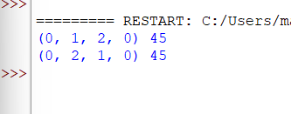
Result: The possible routes and their costs were calculated.

10. A* Algorithm
Aim: To implement the A* search algorithm.
Procedure:
• Open Python IDLE.
• Type the program and save it as a .py file.
• Press F5 to run the program.
• Enter the required input, if any.
• Observe and verify the output.
PROGRAM:
import heapqg = {'A':[('B',1),('C',3)],'B':[('D',2)],'C':[('D',1)],'D':[]}h = {'A':3,'B':2,'C':1,'D':0}q = [(3,0,'A')]while q: f,c,n = heapq.heappop(q) if n == 'D': print("Cost:",c); break for x,w in g[n]: heapq.heappush(q,(c+w+h[x],c+w,x))
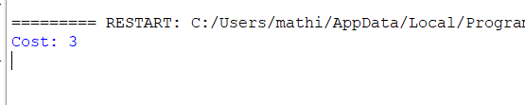
Result: The A* algorithm calculated the cost of a path to the goal.

11. Map Coloring using CSP
Aim: To color map regions without adjacent regions having the same color.
Procedure:
• Open Python IDLE.
• Type the program and save it as a .py file.
• Press F5 to run the program.
• Enter the required input, if any.
• Observe and verify the output.
PROGRAM:
g = {'A':['B','C'],'B':['A','C'],'C':['A','B']}colors = ['Red','Green','Blue']r = {}for a in g: for c in colors: if all(r.get(n)!=c for n in g[a]): r[a]=c breakprint(r)
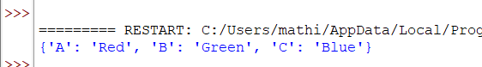
Result: Colors were assigned to regions without conflicts.

12. Tic-Tac-Toe Game
Aim: To implement a simple Tic-Tac-Toe game.
Procedure:
• Open Python IDLE.
• Type the program and save it as a .py file.
• Press F5 to run the program.
• Enter the required input, if any.
• Observe and verify the output.
PROGRAM:
b = [' ']*9wins = [(0,1,2),(3,4,5),(6,7,8), (0,3,6),(1,4,7),(2,5,8), (0,4,8),(2,4,6)]for i in range(9): print(b[:3],b[3:6],b[6:]) p = int(input("Position 1-9: "))-1 if p not in range(9) or b[p]!=' ': print("Invalid"); continue b[p] = 'X' if i%2==0 else 'O' if any(b[a]==b[c]==b[d]!=' ' for a,c,d in wins): print(b,"Winner:",b[p]); break
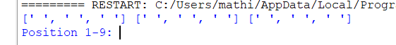
Result: A simple Tic-Tac-Toe game was implemented.

13. Minimax Algorithm
Aim: To implement the Minimax algorithm for game playing.
Procedure:
• Open Python IDLE.
• Type the program and save it as a .py file.
• Press F5 to run the program.
• Enter the required input, if any.
• Observe and verify the output.
PROGRAM:
def minimax(t,m): if isinstance(t,int): return t v = [minimax(x,not m) for x in t] return max(v) if m else min(v)print(minimax([[3,5],[2,9]],True))
Output:
3
Result: The best score was selected using the Minimax algorithm.

14. Alpha-Beta Pruning
Aim: To implement Alpha-Beta Pruning for game playing.
Procedure:
• Open Python IDLE.
• Type the program and save it as a .py file.
• Press F5 to run the program.
• Enter the required input, if any.
• Observe and verify the output.
PROGRAM:
def ab(t,a,b,m): if isinstance(t,int): return t v = float('-inf') if m else float('inf') for x in t: r = ab(x,a,b,not m) v = max(v,r) if m else min(v,r) a = max(a,v) if m else a b = min(b,v) if not m else b if a>=b: break return vprint(ab([[3,5],[2,9]],float('-inf'),float('inf'),True))
Output:
3
Result: The best score was found using Alpha-Beta Pruning.

15. Decision Tree
Aim: To implement a simple decision tree using Python.
Procedure:
• Open Python IDLE.
• Type the program and save it as a .py file.
• Press F5 to run the program.
• Enter the required input, if any.
• Observe and verify the output.
PROGRAM:
import numpy as np

# Sigmoid activation function
def sigmoid(x):
return 1 / (1 + np.exp(-x))

# Derivative of sigmoid
def sigmoid_derivative(x):
return x * (1 - x)

# Feedforward neural network class
class FeedforwardNeuralNetwork:
def __init__(self, input_size, hidden_size, output self.input_size = input_size
self.hidden_size = hidden_size
self.output_size = output_size

# Initialize weights and biases
self.weights_input_hidden = np.random.rand(input_size, hidden_size)
self.biases_hidden = np.random.rand(hidden_size)
self.weights_hidden_output = np.random.rand(hidden_size, output_size)
self.biases_output = np.random.rand(output_size)

def forward(self, X):
# Hidden layer
hidden_input = np.dot(X, self.weights_input_hidden) + self.biases_hidden
hidden_output = sigmoid(hidden_input)

# Output layer
output_input = np.dot(hidden_output, self.weights_hidden_output) + self.biases_output
output_output = sigmoid(output_input)

return output_output

# Example usage
if __name__ == "__main__":
# Input data (X) and labels (y)
X = np.array([[0, 0], [0, 1], [1, 0], [1, 1]])
y = np.array([[0], [1], [1], [0]])

# Create a neural network with 2 input neurons, 2 hidden neurons, 1 output neuron
nn = FeedforwardNeuralNetwork(input_size=2, hidden_size=2, output_size=1)

# Predict
predictions = nn.forward(X)
print("Predictions:")
print(predictions)
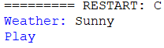
Result: A decision was made based on the given weather condition.

